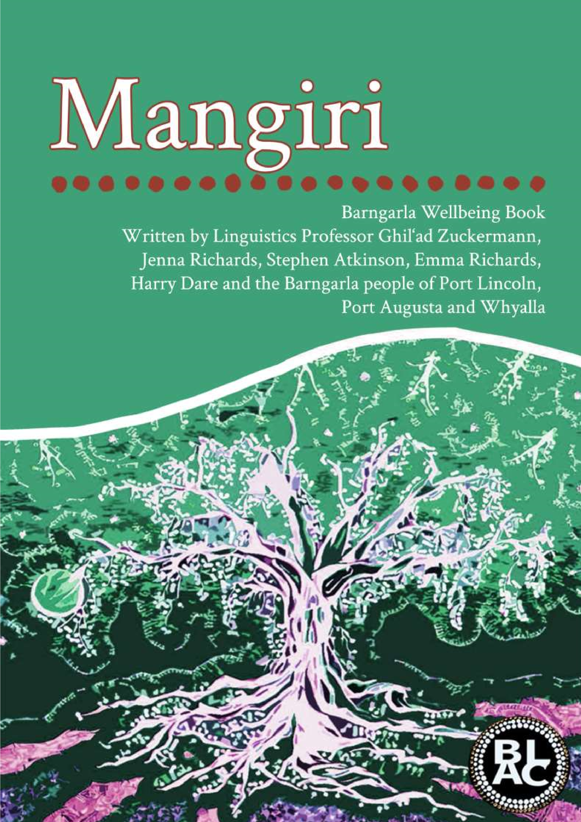

1



DISCLAIMER: Please note that this book is not a comprehensive dictionary of the Barngarla language and does not

include every single word of Barngarla. More than 3000 Barngarla words are available on the website

www.barngarlalanguage.com and through the

*Ba*

*rngarla Language App*

developed for both iPhone and Android.

Further information and material are also available at our Facebook Group Page ‘

*Barngarla Peoples of South Australia*

’.

Any use of any material from this book should be first approved by BLAC.

Abo

ut this Book and the Barngarla Language Reclamation:

Based on material recorded by Revd Clamor Wilhelm Schürmann in the 1840s, the Barngarla language reclamation

has been undertaken since 2011 by Professor Ghil‘ad Zuckermann, Chair of Linguistics and Enda

ngered Languages at

the University of Adelaide, working with the Barngarla Language Advisory Committee (BLAC) on behalf of the

Barngarla communities of Port Lincoln (Galinyala), Whyalla (Waiala) and Port Augusta (Goordnada).

This book has been developed by

revivalist

-

linguist Professor Ghil‘ad Zuckermann (The University of

Adelaide

)

. It is meant to assist the Barngarla community in continuing their project to reclaim their ‘Dreaming,

Sleeping Beauty’ tongue. The creation of the book was supported by ILA (In

digenous Languages & Arts, Department

of Communications & the Arts, Government of Australia), NHMRC, Hakeem Beedar,

Petter Naessan

and the

Barngarla Language Advisory Committee (BLAC).

Design of Book by Jenna Richards 20

20

©

Cover Page and Background Artwo

rk by Vera Richards 20

20

©

Artwork within book by members of the Barngarla Community including

Vera Richards,

Colleen and Candace Taylor

20

20

© Photography within book by members of the Barngarla Community, Photographer Ekaterina Shipova Bell

20

20

©, Profe

ssor Ghil‘ad Zuckermann and stock photos.

**Contact Person/s:**

**Professor Ghil‘ad Zuckermann**

0423 901 808

ghilad.zuckermann@adelaide.edu.au

**BLAC Chairperson Stephen Atkinson**

0499 224 019

statkinson72@gmail.com

**BLAC Member Jenna Richards**

0473 679 389

jenna21richards@hotmail.com

**BLAC Member Emma Richards**

0459 188 536

karkalla75@hotmail.com

**BLAC Member Harry Dare**

0413 618 298

harold.dare@gmail.com

*\* Permission has been received from appropriate family members for the use of photographs of any children &*

*deceased persons*

*within this book.*

**BARNGARLA LANGUAGE ADVISORY COMMITTEE**

**Website:**

www.barngarlalanguage.com

**Email address:**

BLAC00@outlook.com.au

“If you talk to a man in a language he

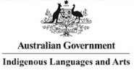understands, that goes to his head. If you talk to him in his language, that goes to his heart.”

# Nelson Mandela

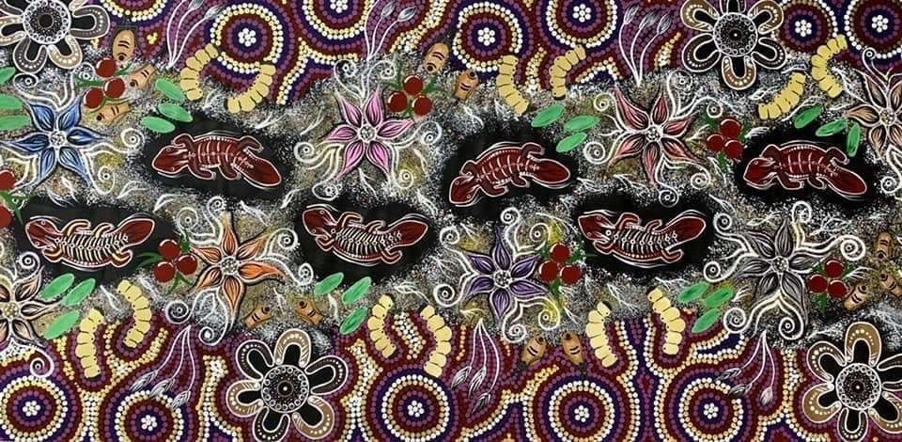

***WELCOME TO COUNTRY***

## WELCOME TO COUNTRY

***Ngarrinyarlboo Barngarlamadha nhai yoorarri yardalyga, wardarnalyga, gawoolyga indoo.***

***Ngarrinyarlboo nhagoodhoo wilya ngamirri babirri galgarridni barnmalyga.***

***Ngarrinyarlboo Barngarlamadha, yarda, wardarna, gawoo galgarridhi malboorri, Badharra Wambirri yoorarriroo.***

***Ngarrinyarlboo Barngarlamadhanga yarda wardarna gawoo moondalyabmidhi, yarda wardarna gawoo Badharra Wambirri yoorarriroo.***

***Ngarrinyarlboo nhagoodhoo wilya yoorarri boogininya, ngarrinyarlbooroo ngamirri babirri yardalyga – ngamirri babirri boogininya, yadhanyaroodni, wildyalidni.***

***Ngarrinyarlboo nhagoodhoo mirinya yoorarri wardandanga, mirinya yoorarri yagalarri gayalanga, inhamadha yarda malboorri. Ngarrinyarlboo nhagoodhoo mirinya yoorarri idna galgarridningi ngoogadha, idna gadnyinirri, gabmoonarri, mangartirri, dhabmoortirri. Idna widla moordoo ngarlarri wardandanga yarnbalanidhi.***

***Ngarrinyarlboo nhagoodhoo mirinya yoorarri wardandanga, mirinya yoorarri yagalarri gayalanga. Ngarrinyarlboo inhamadha nganyadha, inhamadha mundultu yoorarringi warirridhi, mirinya yoorarri goodyoolganhadningi warirridhi.***

*We are the Barngarla people, the first people of this country and of the sea and the water.*

*We honour the spirits of our mothers and fathers gone before us.*

*We are the Barngarla People, the traditional custodians of the ancestral lands, seas and waters of the Lower Eyre Peninsula.*

*We the Barngarla People have deep feelings of attachment and connection to the country, seas and waters of the Lower Eyre Peninsula.*

*We pay our respects and honour the spirits of our Elders, our mothers and fathers of this land - past, present and future.*

*We acknowledge Aboriginal and Torres Strait Islander People as the original inhabitants of Australia and recognise these unique cultures as part of the rich cultural heritage of all Australians.*

*We recognise the important role that Aboriginal and Torres Strait Islander People have within community and country.*

## SOUNDS

An explanation of letters, sounds and pronunciations

The following letters make up the Barngarla Alphabet:

**a g ng rl ai i nh rn aw ii ny w b l oo y**

**d ly r**

**dy m rr dh n rd**

|  |  |
| --- | --- |
| **Vowels** | |
| **a** | as in the English words p**a**p**a**, vis**a** |
| **i** | as in the English words b**i**t, s**i**t, p**i**t |
| **ii** | as in the English words t**ea**, k**ey**, sk**i** |
| **oo** | as in the English words p**u**t, b**u**tcher |
| **Diphthongs**  (combinations of two vowels) | |
| **ai** | as in the English words p**ie**, sk**y** |
| **aw** | as in the English words p**ow**er, t**ow**n |
| **Consonants** | |
| **g l m n w y** | These sounds are pronounced basically the same as in English. |



**Two-letter sounds**

There are many two-letter sounds in the Barngarla alphabet. In English a *‘sh’* like in *‘wa****sh****ing’* does not simply represent an *‘s’* followed by an *‘h’*, in the same way *‘dy’* does not mean a *‘d’* followed by a *‘y’* in Barngarla. The letters *‘dy’* represent a single sound.

The following sounds are made by putting your tongue against the roof of your mouth:

|  |  |  |
| --- | --- | --- |
| **Two-letter sounds** | | |
| Sound | Explanation | Example |
| **dy** | as in the English word **j**udge | bi**dy**indi (*smooth,*  *soft*)  **dy**imba (*ashes*) |
| **ly** | as in the English words mi**lli**on, wi**ll y**ou | barda**ly**a (*scar*) bi**ly**i**ly**a (*butterfly*) |
| **ny** | as in the English o**ni**on | na**ny**a (*lean, ugly*) gad**ny**a (*stone, rock*) |
| The following sounds are made by sticking your tongue | | |

between your teeth:

|  |  |  |
| --- | --- | --- |
| **dh** | ‘*dh’* is a *‘d’* pronounced with the tongue outside your mouth. A sound between the sound of the English words **th**is and **d**ust | **dh**adli (*spit*) gan**dh**i (*thigh*) |
| **nh** | as in the *‘n’* in the English word te**n**th | **nh**ayirri (*sky, heaven*) ba**nh**a (*he, she, it*) |

The following sound is made by putting the back of your tongue on the roof of your mouth:

|  |  |  |
| --- | --- | --- |
| **ng** | as in the English words ri**ng**i**ng**, si**ng**i**ng**, lo**ng** | **ng**ama (*breast, milk*) ganba **ng**ooroo  (*whiskers*) |

The following sounds do not occur in English but are made with your tongue tip curled back behind your teeth *(like in Indian languages):*

|  |  |
| --- | --- |
| Sound | Example |
| **rd** | boo**rd**li (*star*) |
| **rl** | nga**rl**a (*much, plenty, many*) |
| **rn** | nga**rn**arra (*north-east wind*) |
|  |  |

|  |  |  |
| --- | --- | --- |
| **r-sounds** | |  |
| Sound | Explanation | Example |
| **r** | as in the English word **r**oa**r**ing | Bi**r**a (*moon*) |
| **rr** | *‘rr’* as in the top or a flap of Japanese, which can also be heard when an American person pronounces the *‘t’* in wa**t**er | wa**rr**i (*wind*) |

When spoken slowly, or for emphasis, the *‘rr’* is pronounced as a rolled *‘r’* trilled, like in Italian, (as in *‘Fe****rr****a****r****i’*)Spanish and Scottish English.

## Barngarla Songs

### Song 1: 1 John 4:18

|  |  |
| --- | --- |
| ***Bandya gooda wayi-yooloorroo.***    ***Wilya bandya waroongoo wayi maldhinoonggoodhoo*** | *There is no fear in love,*    *Because perfect love casts out fear.* |

Even though the English is pretty simple, it’s hard to translate the above text into Barngarla exactly. Let’s explain the proposed translation.

This is the suggested translation of *“There is no fear in love”*:

*“Bandya gooda wayi-yoorloorroo.”*

This is the ‘interlinear gloss,’ a breakdown of the sentence:

bandya gooda

<bandyarrgidhi ‘to love, be glad’ NEGATIVE wayi-yoorloorroo afraid, fear-ASSOCATIVE

‘Love’ is an abstract concept that doesn’t exist in the physical world, so different cultures have come up with different ways of talking about it.

In Barngarla, it seems to be a verb: *“bandyarrgidhi.”*

We have to break this word down to make it a noun. To do this, first, we have to split it in half. We know how to do that by looking at other Barngarla words that have similar parts *and* have been recorded as separate types of words.

For example, look at *“moorrgoorrigdhi”* (Eng.: *“to swell”*).

It’s related to the word *“moorrgoomoorrgoo”* (Eng:

*“swelling”)*. So, if we take away the repeated part, we get *‘-rrgidhi.’* It’s not known what this means (except we know that *‘-dhi’* is for show that it is past tense).

You can see this part is also in *“bandyarrgidhi,”* so if you take it away, you can make a new word for love, *“bandya.”*

In Barngarla, saying *“****in*** *love,”* doesn’t sound natural. So, it is necessary to change the way you say the sentence, but keep the same meaning.

*“(There is) no fear associated with love”* is appropriate.

The word for *‘with’* (*‘-yoorloorroo’)* has to be put on the end of the noun it is associated with. In this case that is

“wayi.”



*“Wilya bandya waroongoo wayi maldhinoonggoodhoo”* wilya bandya waroo-ngoo soul, spirit <bandyarrgidhi, to love, be glad true-ERGATIVE wayi maldhi nhoo-nggoo-dhoo afraid, fear night, dark give-CAUSATIVE-PRESENT

“Because” is an important word, but in the historic Barngarla records, it is nowhere to be found. We think that it maybe was implied, so it’s not necessary to be outright said.

On its own, “bandya” can’t do an action from a linguistics perspective. So, we change “love” to the idea of “the spirit of love” by adding *“wilya.”*

Then, we also add *“waroo-ngoo.”* “Waroo” means true, and putting “-ngoo” on the end lets us know that our entire phrase “wilya bandya waroo” is acting on “wayi.”

The closet translation of *“cast out”* might be *“maldhi nhoonggoodhoo”* meaning *“to kill,” “send out of the world.”*

So, finally, when we consider all this information, we get

the above translation. It’s literally *“the spirit of true love*

*sends fear out of the world.”*

### Song 2: The Whole Entire World

***Yoorra badlooyoonoo*** *The whole world*

***widla mirinya; widla wilgoorndoo*** *is very narrow bridge,* ***bari waloonga garngara.***

***Gooda waiigoomaga!*** *but the main thing is not to fear at*

*all.*

In Barngarla there is no word for ‘bridge,’ so to say it, we have to work out other ways of describing a bridge. A bridge is pretty much a narrow passage to cross water, in this case literally *“widla”* (Eng.: *“path”*) matches the idea. So, when we combine it with *“bari”* we get *“bari widla”* which has a similar meaning to the English “bridge.”

Instead of finding a perfect translation, sometimes it’s necessary to describe it as something similar.

Similarly, there is no way to say “the main thing” in Barngarla, so instead the last sentence was completely changed to be a command meaning “Have no fear!” — even though it’s not a word-for-word translation, the idea is still there.

Literally the translation means *“the whole earth is similar to a path, a very narrow interval path above a river, but have no fear!”*

### Song 3: A Walk to Caesarea

***Wilya galgarridni imini, ngaidyi***  *O Lord, My God,*

***Oorndakarra!***

***Ngadhoo nhina ngoowadha inha yadna*** *I pray that these things shall never* ***gooda madlanidhi.*** *end.*

***Moorroo, wardarna,*** *The sand and the sea,*

***Baldoo wandoobidni,*** *The rush of the waters,*

***Goorrana ilgaringi,*** *The crash of the heavens,*

***Yoorarriroo ngoowalyga wabara.*** *The prayer of Man.*

wilya galgarridni imini soul, spirit ancient sacred ngaidyi Oorndakarra

my God ngadhoo nhina ngoowadha inha yadna I-ERGATIVE you-ACCUSATIVE pray those.there gooda madlanidhi NEGATIVE to.become.no.more moorroo wardarna sand sea

baldoo wandoo-bidni

sound wave-RELATIVE/ASSOCIATIVE goorrana ilgari-ngi thunder sky-LOCATIVE

If you look at the interlinear gloss, the meaning of the line “O Lord, my God” has been changed a bit. There is no recorded word for ‘God’ in Barngarla, so *“Oorndakarra”* was borrowed from Adnyamathanha for the translation.

Another way of saying *“will never end”* could be “always remainin’,” which in Barngarla would be:

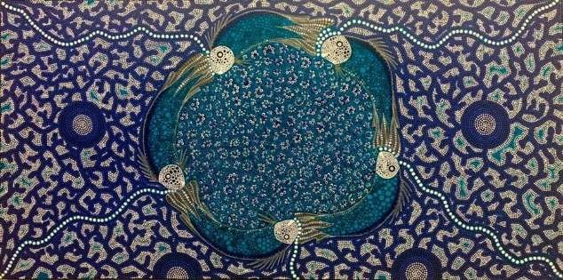gabmarra wandarri-yooroo always remain-INFINTIVE/PURPOSIVE

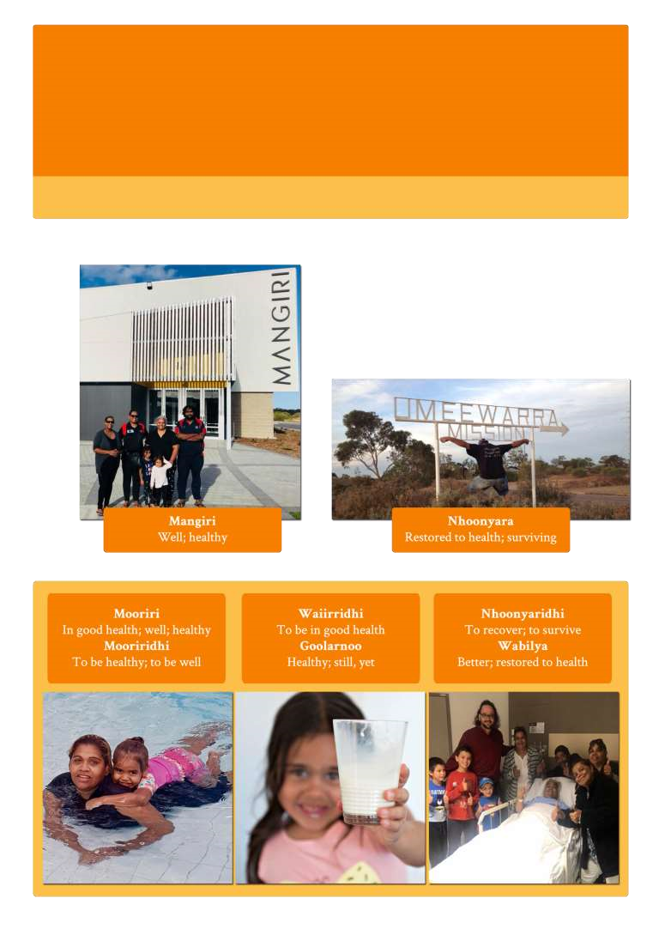

**Barngarla Wordlist**

Health

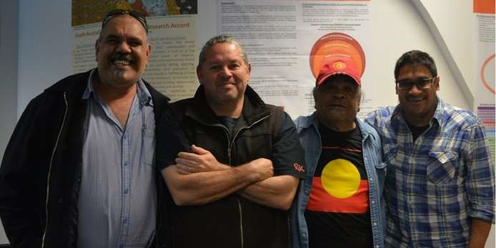

### Nhoonyara igadha; gayabidni gooda badloodhoo

*He will survive; he won’t die of the spear wound*

Literally: *“Surviving live”;* spear (gaya) from (-bidni) not to die

**Did you notice?**

Notice the difference between *mooriri* and *mooriri****dhi****?*

In Barngarla, some action words have been made by adding *dhi* (meaning *“to be”)* to a describing word, making a new word.

You will see this happen again in the next wordlists.

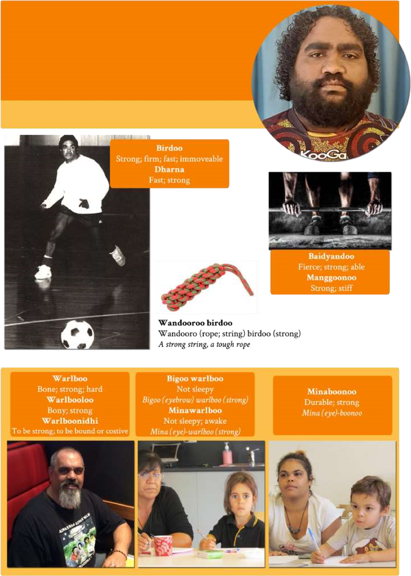

**Barngarla Wordlist**

Strong

|  |  |  |  |
| --- | --- | --- | --- |
| **Balyamba** |  |  | Weak |
| **Banggooroo** |  |  | Weak |
| **Boorara** |  |  | Weak |
| **Gabara** |  |  | Weak |

“*Warlboonidhi”* is also made of other, smaller pieces. “*Ni”* makes a

‘being’/‘existing’ verb out of *“warlboo.” “Dhi”* means the action is happening now. Sometimes, instead of *“–ni”* you’ll see *“–rri”* used. It works in the same way.

**Minimal pair**

A minimal pair is when there’s only **one** in a word that makes it different from another word. If you change the one sound, you get totally different words. **m**anggooroo *“strong”* **b**anggooroo *“weak”* wa**nh**a *“which; what; where”* wa**rd**a *“stump; stem”* wa**lh**a *“wild turkey”* wa**rn**a *“belly”* **y**abma *“back of a man”* **w**abma *“wise”*

***“Minawarlboo” memoriser:*** *When you are asleep, your eyes fall down, they are weak.*

*Mina (eye) warlboo (strong):* ***not sleepy; awake***

**Seat of emotions**

In English, the seat of emotions is the heart. For example, think about the expression *“heartbroken.”*

On the other hand, the seat of emotions in many Aboriginal languages is the belly.

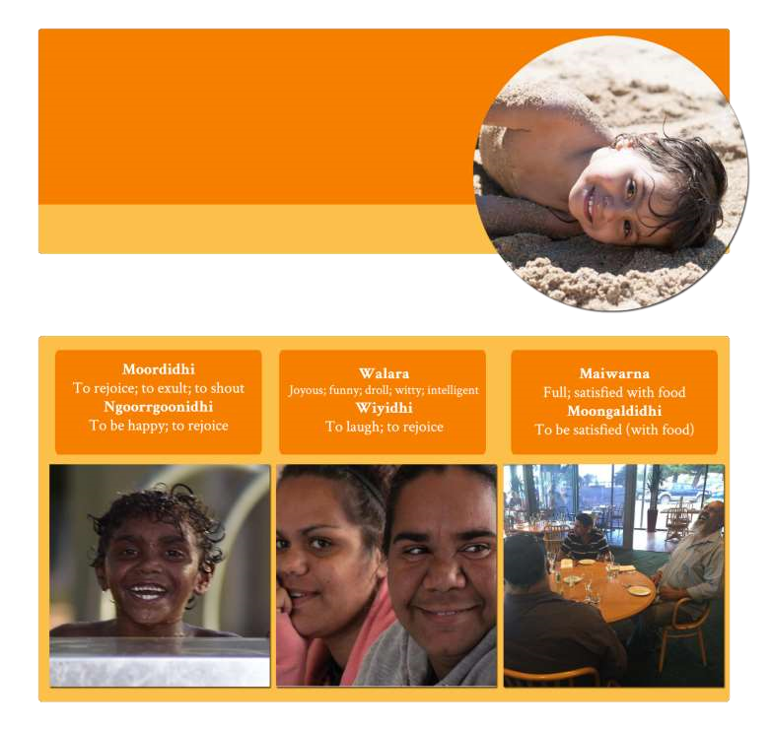

Happy

**Barngarla Wordlist**

***Moordi***

*)*

*salmon*

*(*

*-*

***dhi***

*(*

*Aboriginal*

*people*

*would express their joy when they saw the*

*shoal of a fish)*

Let’s take a look at some Western Desert languages like Yankunytjatjara, Pitjantjatjara and several others:

When Aṉangu say *“ngayulu tjuni pika”* *(I — belly — pain/hurt/trouble)* it usually means *“I’m worried!”*

When Aṉangu talk about someone being angry, they often say *“liri waru”* *(throat — fire).* For Aṉangu, the throat is the place that gets fired up and wild.

|  |  |
| --- | --- |
| **Barngarla** | **Meaning Literally** |
| **Warna gardindya** | Glad *Belly blood* |
| **Warna moondalya** | Glad; merry *Belly sweet* |
| **Warna moondalyidhi** | To feel glad |
| **Warna waiiri** | Glad; pleased *Belly healthy* |
| **Warna waiirridhi** | To be pleased |
| **Yoori mandyari**  *Ear nice* | In good humour; glad; merry |
| **Yoori marnidhi** | To be in good humour; glad; merry |

*Ear good-to be*

The liver, *“ngaldi”* is also used to describe feelings.

|  |  |
| --- | --- |
| **Barngarla** | **Meaning** |
| **Ngaldi bagambidhi** | Sympathise (*literally “liver is full”)* |
| **Ngaldi mirirarridhi** | Be without feeling; merciless |
| **Ngaldi moorirridhi** | Feel well *(lit. “liver is healthy”)* |
| **Ngaldi ngoodharridhi** | Worry; fret *(lit. “liver breaks out”)* |
| **Ngaldi yaldadha** | Rejoice; celebrate |

**Gabagadha** To love; to court

**Moodhladha** To make love; to court

**Did you know?**

*“Moodhla”* means *“nose,”* and also *“extreme point of something.”* Think about the hongi in Māori culture.



**Barngarla**

**Meaning**

**Gabadidhi**

To love; to court a

woman

**Barngarla Wordlist**

Love

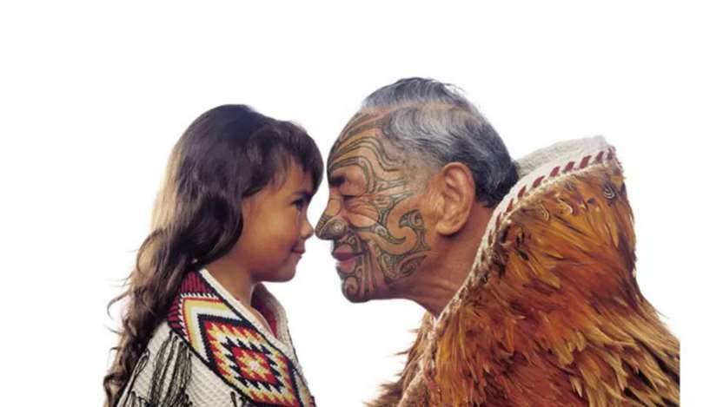

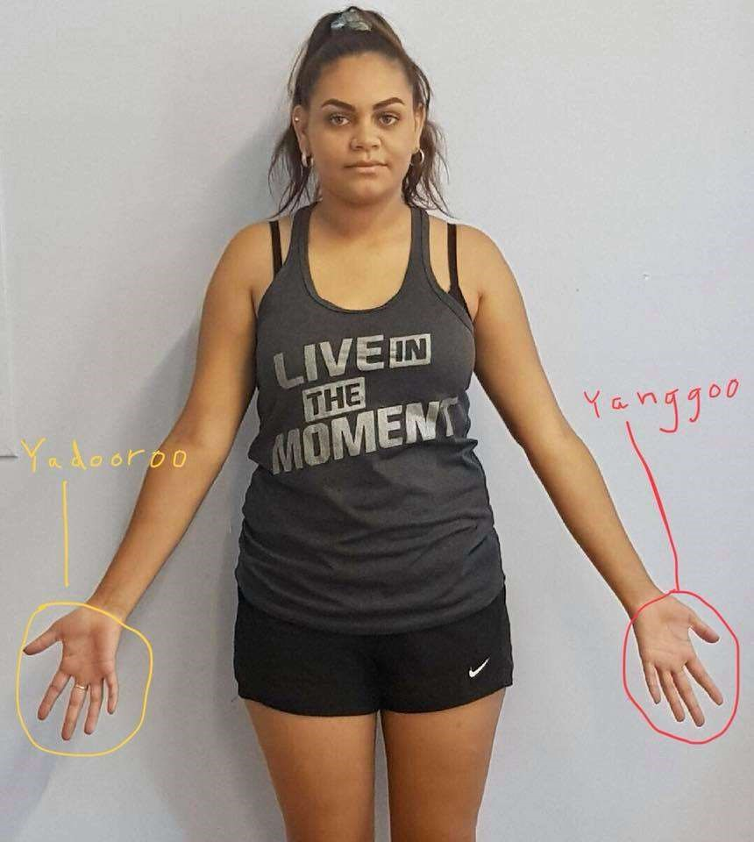



**Barngarla**

**Wordlist**

Friend

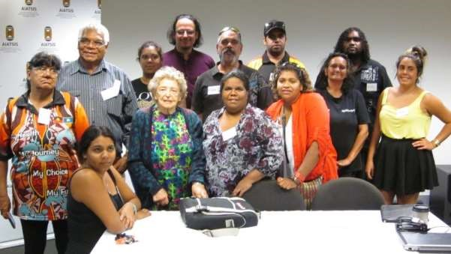

|  |  |  |  |
| --- | --- | --- | --- |
| **Barngarla** |  |  | **Meaning** |
| **Babarngoo** |  |  | Old acquaintance; friend |
| **Goonyala** |  |  | Friend; relation |
| **Maliri** |  |  | Peaceable; friendly |
| **Mangarlidhi** |  |  | To be peaceable; to be friendly |

*Marngarli (peaceable)-dhi (to be)*

**Mardana** Acquaintance; friend; person seen before

*Marda (old place)-na (past)*

**Marngarla**  Peace; friendly; friend; (opposite of hostile)

**Mooyoonara** Safe; unharmed; preserved

**Ngalira** Friend; confidant

**Ngananda**  Friendly; hospitable

*“Ngai (yoora) Barngarla marngarla.”*

“I am a friendly

Aboriginal (person).”

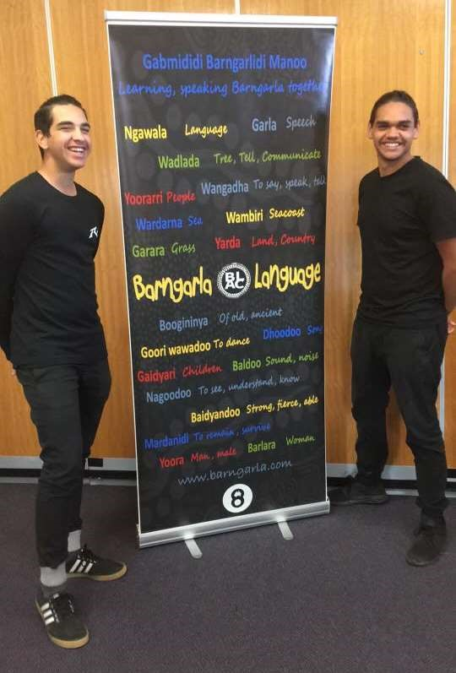

*“Mirinya gawoo maraba mooyoonara badnadawoo.”*

“An Aboriginal person can travel safe(ly) without water.”

**Mirinya** (an Aboriginal) **gawoo** (water) **maraba** (without) **mooyoonara**

(safe) **badnadawoo**

(walk)

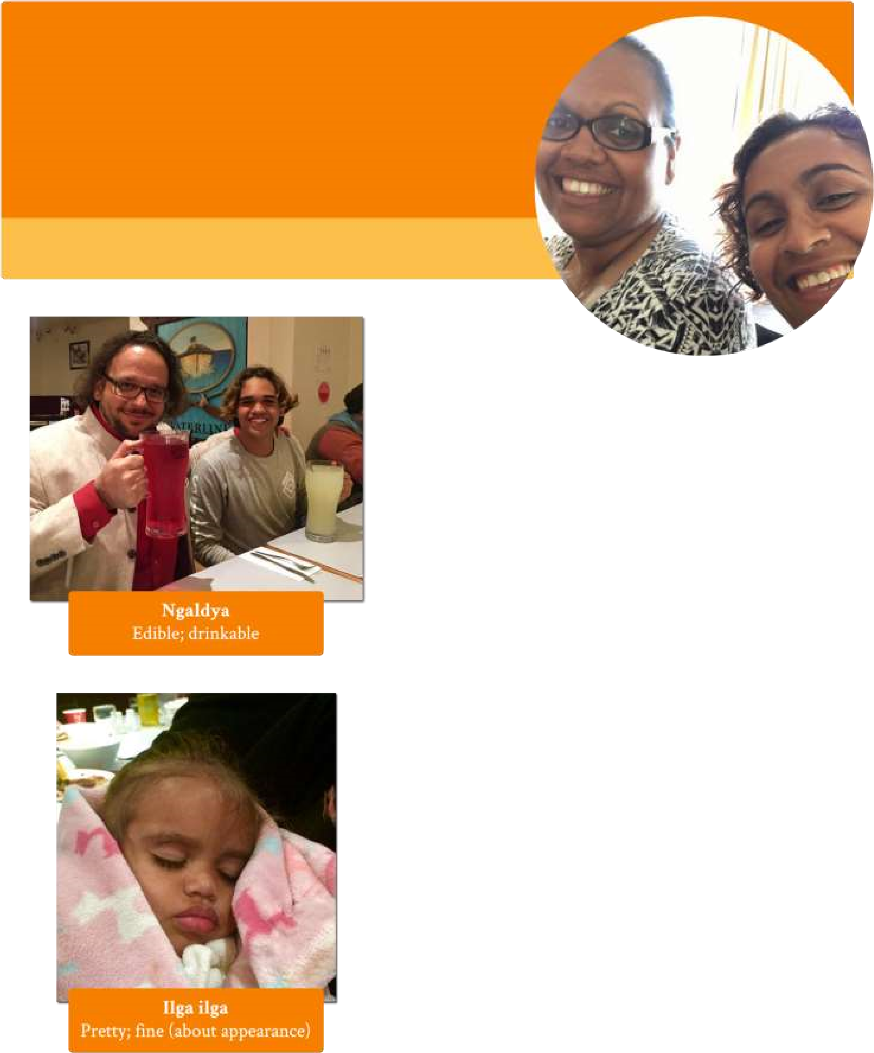

Nice

**Barngarla Wordlist**



**Barngarla**

**Meaning**

**Mandyari**

Fine; right; nice

**Moondalya**

Sweet; nice

**Ngaldya**

Edible; drinkable

**Ngamboolya wanggadha**

To talk sweetly

**Ngandya**

Dear; sweet;

pretty; mindful

**Ngandyangandya**

Very dear; very

sweet; very pretty

**Nganyara**

Sweet

**Yarldarrbi**

Fresh; sweet

Rich

**Mai**

**-**

**ilgana**

Having food; rich



**Gabi yarldarrbi/Gawoo yarldarrbi**

Fresh water

